

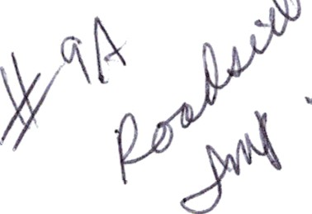Delaware Fedcratiori of Garden Clubs

Awards Application 2021 - 2023

First Place

Second Place ’” ’J

T hirri PiaCe

fJonorabiu Mention t

**Applicatan** for State **Awards to be** submitted **by Nov 11. Yearbooks are due Oct 1.**

Other **deadline exceptions are** detailed **on the OFGC Awards Schedule Sheet.**

**Mail application to State Awards Chairman: Marv Williford.** 24900 **Maonolia Circle Millst›oro OE** \ 9966 Email: mewtlliford *ver›• n net Phone: (302) 934 J7

Award Name: Roadside Improvement - Beautification

Garden Club: Coastal Gardeners

Award #: 9A

Number of Members 40

Club President: Sandy Daniels Phone: 203-788-3813 Email: [sbdsun@aol.com](mailto:sbdsun@aol.com)

Awards Chairman: Donna Buono Phone: 732-763-326 Email: [donnabuono2@gmaiI.com](mailto:donnabuono2@gmaiI.com)

Awards application form is limited to three printed pages*, except where noted on the DFGC Awards Schedule Sheet, front of pages only. No report covers, binders or plastic sheets are allowed. Please complete each topic listed below, if applicable. Use numbering that is indicated.

You may use the application form as a cover sheet only, if desired. If you choose to do this, do not add an information that is s

requested. You may then add THREE full pages of project information, photos, etc. to your application.

* NOTE: If you add project information to the application page, it will count as one of the three pages in your application and you may add only TWO more pages.

Application form will not be returned. Exceptions: publications (books, CD/DVD). Copy the completed application for your files.

Forward to CAR-SGC 

# Award Category:

Forward to NGC 

# Award Category:

PLEASE complete each topic, if applicable. Use numbering below when completing the form.

1. New Project: Yes No x Beginning date: 2019 Completion date: on-going
2. Brief summary and objectives of project

Delaware Seashore State Park, Tower Road is located at 38964 Coastal Highway, Rehoboth Beach, DE. It is the park's premier location for beach goers north of Indian River Inlet. The location has a full-service bath house with restrooms, showers, changing area and snack bar, as well as boardwalk access to the beach. A World War II observation Tower on the grounds is currently under renovation to be a future tourist destination. All visitors must access the park via the main entrance and stop at the parking fee booth. Coastal Gardeners are continuing with the planting at the front and back area by Tower Road fee booth. The club has been focusing on planting native plants due to the conditions there. Even with this year's hottest of summers our native selection thrived proving that once established natives can take care of themselves. Since the inception of this project, the club has tried several different varieties of perennials that would tolerate the salt air, heat, drought, wind, flooding, and this year a Nor'easter that lasted for a week. Our persistence paid off and we have finally assembled the perfect combination of perennials.

1. Involvement of club members, other organizations, etc.

Coastal Gardeners, with twenty-one members from the group, worked on many phases of this project from early spring to fall. The project planting was discussed with the expertise from the local nursey owners, Inland Bays Garden Center. Cheryl and Denise specialize in selling native plants at their nursery. The lead garden members do research and work with the garden center. Steps are, first a cleanup in early spring of the garden beds, then planting in May, and followed by weekly watering. Watering has a unique set of problems, as there is no immediate source of water at the booth island. Water must be carried from the bath house (about a quarter mile away) to the booth island. This is done by filling five 5-gallon buckets and jugs with water and transporting them with our vehicles. Club members signup for weekly watering from May to the beginning of October. The project Co-lead keeps an excel sheet and sends out reminders. During the watering, members check for any weeding that needs to be done.

1. Project expenses and means of funding

The plants were selected at the Inland Bays Garden Center who collaborated with the club members. The listed plants were Agastache, Nepeta, Rudbeckia, Lavender, Butterfly Weed, Golden Rod, Switch Grass, Purple Muhly, St. John's Wart, Yucca, Sea Holly, Rattlesnake Master, and Hibiscus. The club selected annuals for a pop of color that did well. Invoice was for $342.00 plus a discount. The Delaware State Parks paid the final bill of $307.80.

1. Continuing involvement, follow-up, maintenance

Thanks to our soil amendments and our team of members who watered from spring to fall we were even able to sustain annuals along with the native plants. If you are driving by stop in and enjoy our little bit of Native Heaven.

1. Attach or insert photos, digital photos and/or landscape plan (does not need to be professionally drawn).

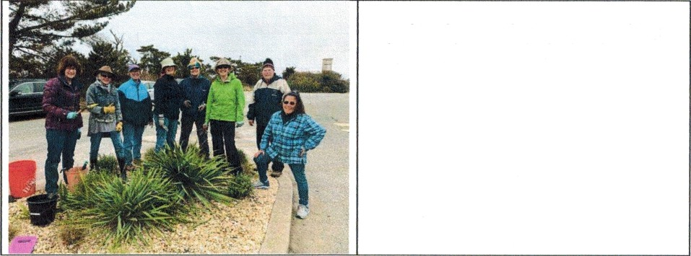

Coastal Gardeners with winter gear on doing early Spring cleanup at the fee booth at Tower Road.

Spring planting with Coastal Gardeners members with Tower in background.

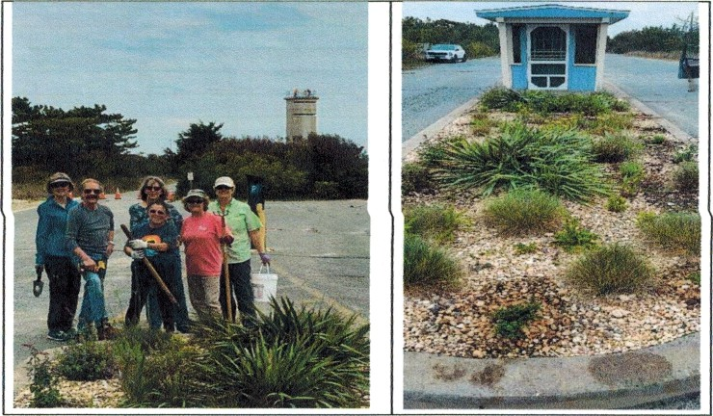

Plants are doing well. Sandy Daniels in photo below.

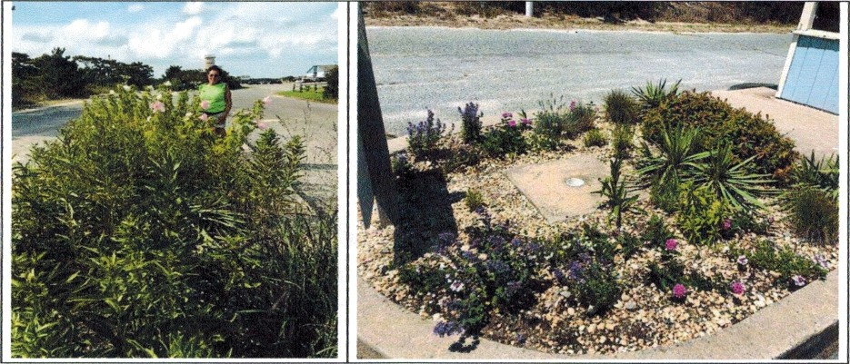

September pictures of the garden beds at Tower Road.

